IDENTIFYING TACTICS
by
GM Bong Villamayor
Powerchess Asia

By chess definition - tactics is the execution of a plan – it is the means to win the game; it is present in every phase of a chess struggle.
The ability to identify tactics depends on how we observe the various interactions of the many pieces in the board. Learning the fundamental motifs/themes and applying it regularly either by exercises or practical play will make us good tacticians.
But always remember: good tactics on your side only comes with sound positions; that’s why we have to value the ideas and principles learned and apply them in our games. We must build up our position correctly to achieve tactics.
As for defense, especially in difficult and inferior positions, the anticipation of opponent’s threats helps us resist longer and even win some cases.

Examples:
1W 2W 3B
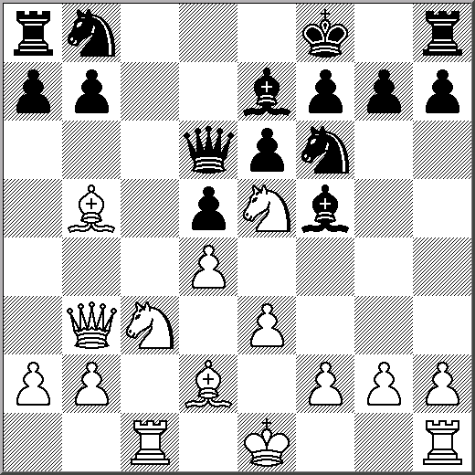
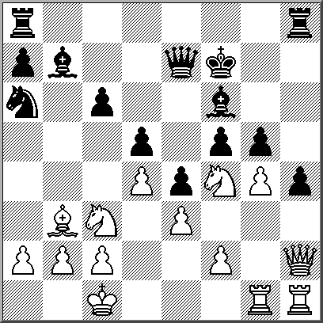
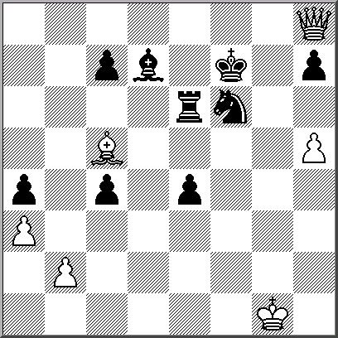

Black has a weakness… How can White create attack? White played h5??

4W 5W 6W
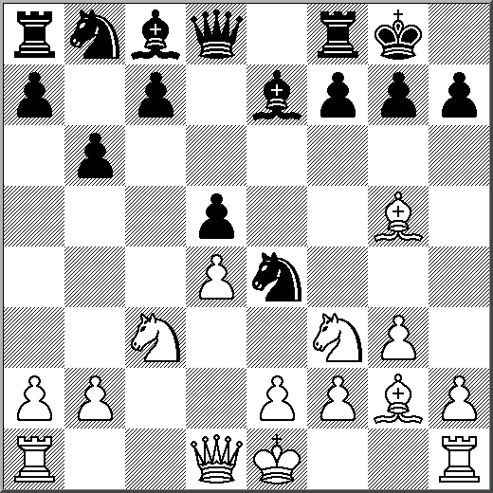
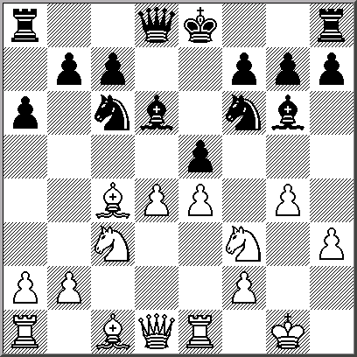
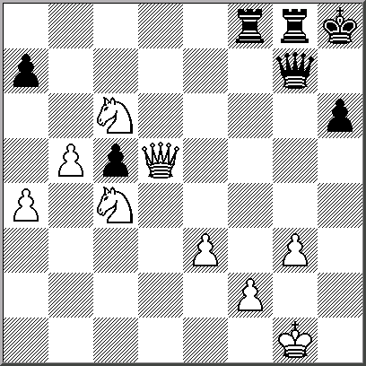

Black played Ne4?? Black opened up with e5?! White played Qxc5?? …

7B 8W 9W
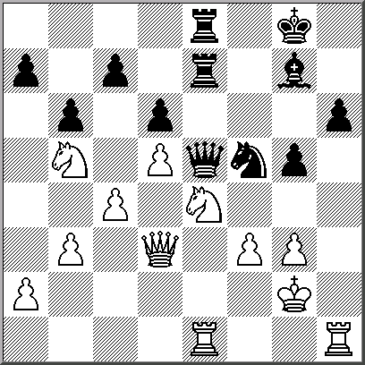
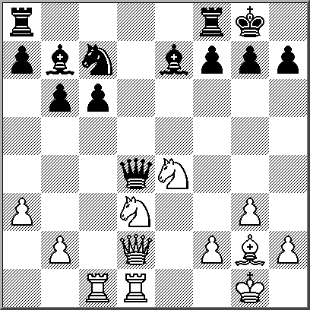
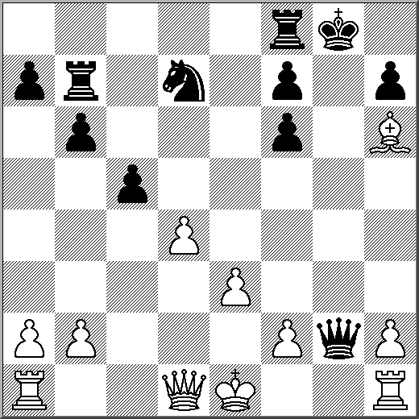

Find Black’s best move… Black just played Qxd4?? Find White’s best move…

EXERCISES

1/B 2/W 3/W
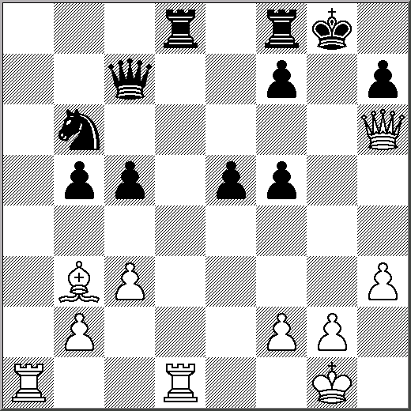
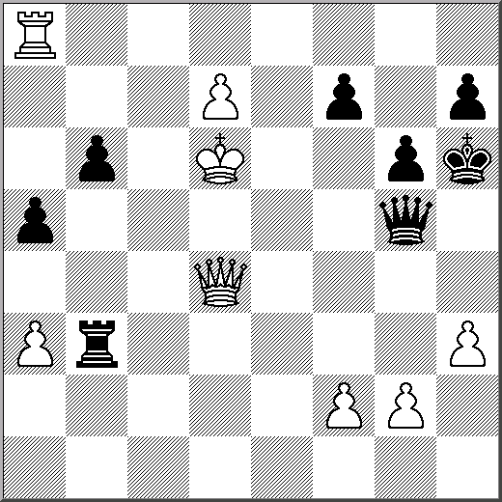
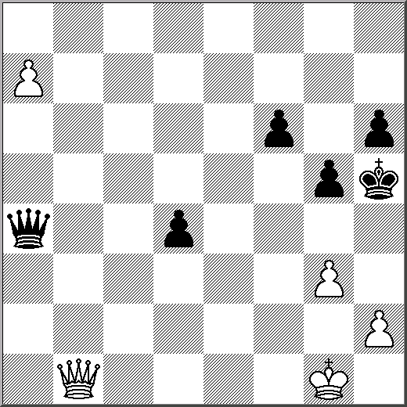

4/B 5/W 6/B
